Many guides about installing Docker, Kubernetes and deploy Kubernetes Dashboard and access it remotely, yet each guide I found required serious extra work and configuration. Should you be someone like me, unhappy with other guides, try this one and let me know how I did.
Prerequisites:
This guide assumes that you have a minimal configuration like this:

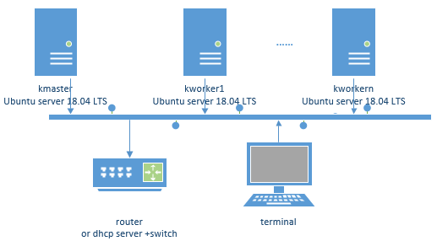
We will use only one master and one worker. In a virtual environment, each server must have at least 2 virtual CPUs.
In this guide master and worker(s) are Ubuntu server(s) 18.04. IPs are fixed, either at server level or reserved at the DHCP level. In my personal case IPs are fixed at the DHCP server level.
The terminal has the ssh feature installed/available.
Installation and configuration
- On the master server
Install Docker distribution version, and check version number
sudo apt-get update
sudo apt-get install docker.io
docker -v

Enable Docker, start Docker and check status
sudo systemctl enable docker
sudo systemctl start docker
sudo systemctl status docker

Docker status should display the service is active. Quit with q .
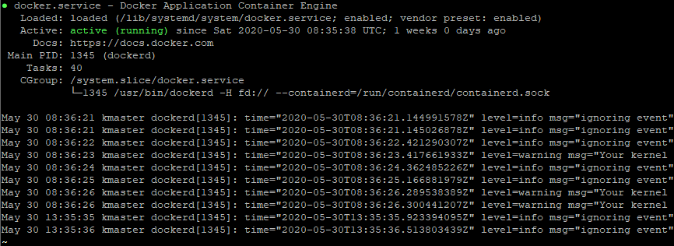

Add repository for Kubernetes
curl -s https://packages.cloud.google.com/apt/doc/apt-key.gpg | sudo apt-key add
sudo apt-add-repository "deb http://apt.kubernetes.io/ kubernetes-xenial main"
sudo apt-get update

Install Kubernetes and verify version
sudo apt-get install kubeadm kubelet kubectl
kubeadm version

Disable swap on the Ubuntu server on every node. Why? Kubernetes is a distributed system that is designed for scalability in a deterministic way. Running large number of containers on several machines require predictability and consistency. Disabling swap is the right approach. Therefore, the kubelet is not designed to handle swap feature. Usually the swap file is /swap.img
sudo swapoff -v /swap.img
sudo rm /swap.img
sudo vi /etc/fstab

Comment out in /etc/fstab the swap related line.
Initialize Kubernetes on the master node
sudo kubeadm init --pod-network-cidr=10.244.0.0/16

Save the join string displayed at the execution end because it is needed to join the workers. The join sting will look like
kubeadm join 192.168.0.14:6443 --token j5c1cn.b6ub4u5r8umwb1bp --discovery-token-ca-cert-hash sha256:a44849c4d31cf517d7f58ea8d5051bdc24561aae642f3bc76a61a9d077b4728e

Create configuration for the cluster
mkdir -p $HOME/.kube
sudo cp -i /etc/kubernetes/admin.conf $HOME/.kube/config
sudo chown $(id -u):$(id -g) $HOME/.kube/config

Deploy Pod Network to Cluster allowing communication between different nodes in the cluster. We use the flannel virtual network.
sudo kubectl apply -f https://raw.githubusercontent.com/coreos/flannel/master/Documentation/kube-flannel.yml

Allow the process to complete and verify everything is running and communicating. All must be running.
kubectl get pods --all-namespaces

Check also the /etc/systemd/system/kubelet.service.d/10-kubeadm.conf file for the driver.
Go to each worker now and follow the steps.
- On each worker
Install Docker distribution version, and check version number
sudo apt-get update
sudo apt-get install docker.io
docker -v

Enable Docker, start Docker and check status
sudo systemctl enable docker
sudo systemctl start docker
sudo systemctl status docker

Docker status should display the service is active. Quit with q .

Add repository for Kubernetes
curl -s https://packages.cloud.google.com/apt/doc/apt-key.gpg | sudo apt-key add
sudo apt-add-repository "deb http://apt.kubernetes.io/ kubernetes-xenial main"
sudo apt-get update

Install Kubernetes and verify version
sudo apt-get install kubeadm kubelet kubectl
kubeadm version

Disable swap on the Ubuntu server on every node. Why? Kubernetes is a distributed system that is designed for scalability in a deterministic way. Running large number of containers on several machines require predictability and consistency. Disabling swap is the right approach. Therefore, the kubelet is not designed to handle swap feature. Usually the swap file is /swap.img
sudo swapoff -v /swap.img
sudo rm /swap.img
sudo vi /etc/fstab

Comment out in /etc/fstab the swap related line.
Join worker node to cluster with the string backed up before
sudo kubeadm join 192.168.0.14:6443 --token j5c1cn.b6ub4u5r8umwb1bp --discovery-token-ca-cert-hash sha256:a44849c4d31cf517d7f58ea8d5051bdc24561aae642f3bc76a61a9d077b4728e

- On the master server
We will deploy Kubernetes Dashboard, a web-based Kubernetes user interface allowing deploying containerized applications to a Kubernetes cluster, troubleshoot your containerized application, and manage the cluster resources. Dashboard provides also an overview of applications running on your cluster, as well as for creating or modifying individual Kubernetes resources (such as Deployments, Jobs, DaemonSets, etc). For example, you can scale a Deployment, initiate a rolling update, restart a pod or deploy new applications using a deploy wizard. Dashboard also provides information on the state of Kubernetes resources in your cluster and on any errors that may have occurred.
kubectl apply -f https://raw.githubusercontent.com/kubernetes/dashboard/v2.0.0/aio/deploy/recommended.yaml

Allow a few moments and check the deployment
kubectl get pods --all-namespaces

All must be running
To access Dashboard using the kubectl command-line tool start the proxy in background
kubectl proxy
^Z
bg

Kubectl will make Dashboard available at http://localhost:8001/api/v1/namespaces/kubernetes-dashboard/services/https:kubernetes-dashboard:/proxy/
By design, the UI can only be accessed from the machine where the command is executed. In order to access it from a terminal in a web browser, few additional steps:
For the Dashboard authentication, create a Dashboard service account in the default namespace
kubectl create serviceaccount dashboard-admin-sa

Bind the service account to the cluster admin role

kubectl create clusterrolebinding dashboard-admin-sa --clusterrole=cluster-admin --serviceaccount=default:dashboard-admin-sa

At the service account creation Kubernetes created also the secrets
kubectl get secrets

In the returned list look for a secret like dashboard-admin-sa-token-????? And get the associated token
kubectl describe secret dashboard-admin-sa-token-?????

Save the token for authentication. Now go to the terminal and create a tunnel to the Dashboard deployment.
- On the terminal
On the terminal computer ssh must be available
Open a command line terminal (cmd on Windows or term on Linux) and create a tunnel with the following command:
ssh -L 8001:127.0.0.1:8001 -N -f -l username ip_address_of_the_master

After that, in a browser, with the url http://localhost:8001/api/v1/namespaces/kubernetes-dashboard/services/https:kubernetes-dashboard:/proxy/#/overview?namespace=default you should be able to display the dashboard. Authenticate with the toke saved before, and you are done.

